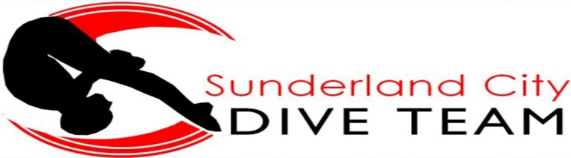
Club Kit Order Form

Club Kit Order Form

Tracksuit Top

Kids £25.50 6-7 (116) 8-9 (128) 10-11 (140) 12-13 (152) 14 (164)
Adults £29 Small (34-36) Medium (38-40) Large (42-44) XL (46+)

Tracksuit Bottoms

Kids £13.50 6-7 (116) 8-9 (128) 10-11 (140) 12-13 (152) 14 (164)
Adults £19 Small (30-32) Medium (34) Large (36) XL (38) XXL (40)

Leggings – reversible

Kids £13.50 7-8 9-10 11-12
Ladies £18.50 XS (8) S (10) M (12) L (14) XL (16)

T-Shirts

Kids £10 6-8 years 9-11 years 12-13 years
Adults £11.50 Small (38) Medium (40) Large (42) XL (44) XXL (46)

Hoody - (comes with initials please state beside size)

Kids £15 5-6 years (28) 7-8 years (30) 9-11 years (32) 12-13 years (34)
Adults £18 Small (36) Medium (40) Large (44) XL (48)

Zip Hoody - (comes with initials please state beside size)

Kids £18 5-6 years (28) 7-8 years (30) 9-11 years (32) 12-13 years (34)
Adults £22 Small (36) Medium (40) Large (44) XL (48)

Name of Diver: Squad:
Item | Size | Quantity | Price | Total

(Tracksuit tops and T-shirts come embroidered with the team logo on the front and Sunderland printed on the back)

